Task 1:
Output:
Top Words in Corpus: [('the', 26451056), ('of', 12507151), ('in', 10807932), ('and', 10758007), ('a', 7988396), ('to', 7681799), ('was', 4588136), ('is', 3746524), ('for', 3145951), ('as', 3066049)]

Word Postions in our Feature Matrix. Last 20 words in 20k positions: [('yarmouth', 19999), ('ami', 19998), ('ub', 19997), ('divert', 19996), ('csa', 19995), ('unlocked', 19994), ('dent', 19993), ('lockout', 19992), ('misuse', 19991), ('sizeable', 19990), ('overt', 19989), ('aqueous', 19988), ('glamour', 19987), ('minerva', 19986), ('madurai', 19985), ('corbin', 19984), ('estadio', 19983), ('ethnographic', 19982), ('rida', 19981), ('melancholy', 19980)]

Spark History:
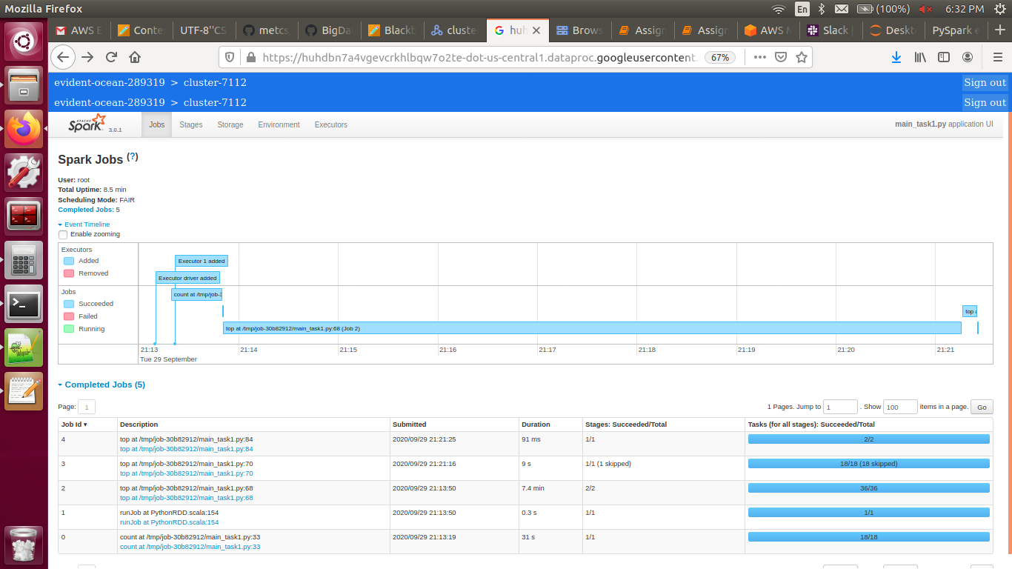
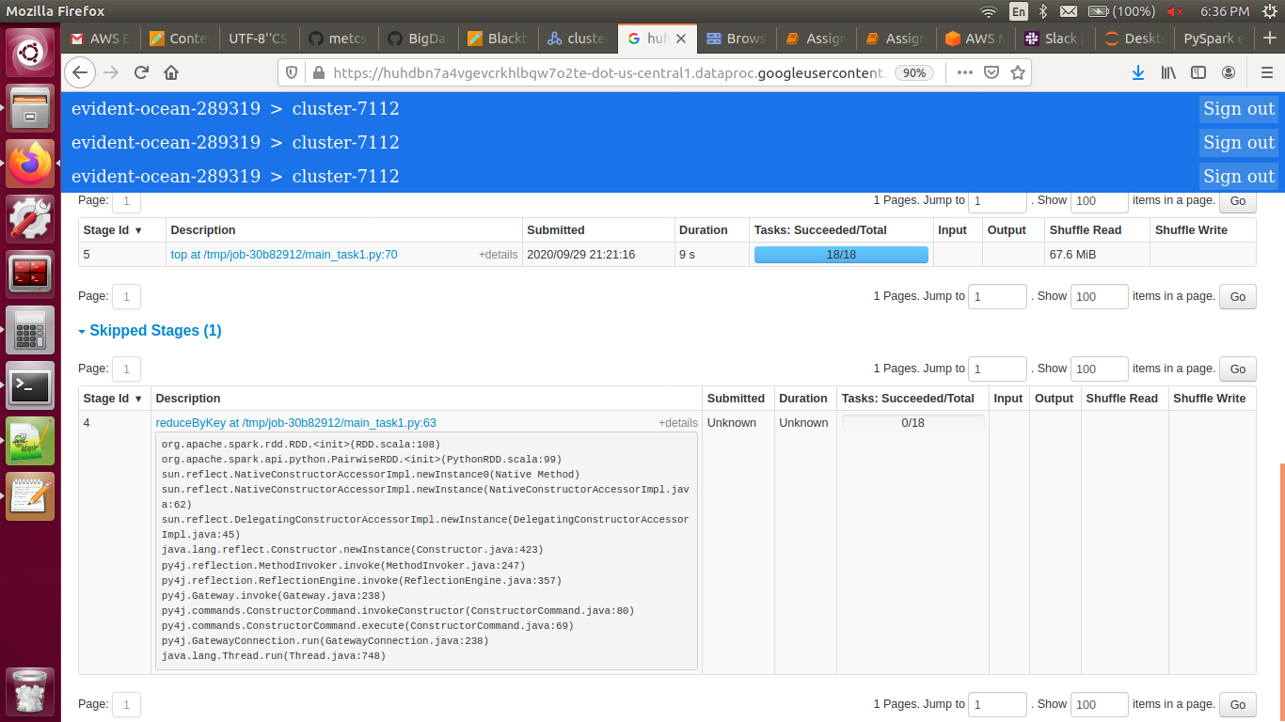

Task 2:
[('414980', array([0.07960966, 0.03903441, 0.04057524, ..., 0. , 0. ,
0. ])), ('23476165', array([0.10526316, 0.0430622 , 0.02392344, ..., 0. , 0. ,
0. ])), ('23551280', array([0.08230769, 0.09538462, 0.03153846, ..., 0. , 0. ,
0. ]))]

[('26805886', array([0.00582409, 0.00427857, 0.00403733, ..., 0. , 0. ,
0. ])), ('27006878', array([0.00800908, 0.00522568, 0.00325312, ..., 0. , 0. ,
0. ]))]

Spark History:
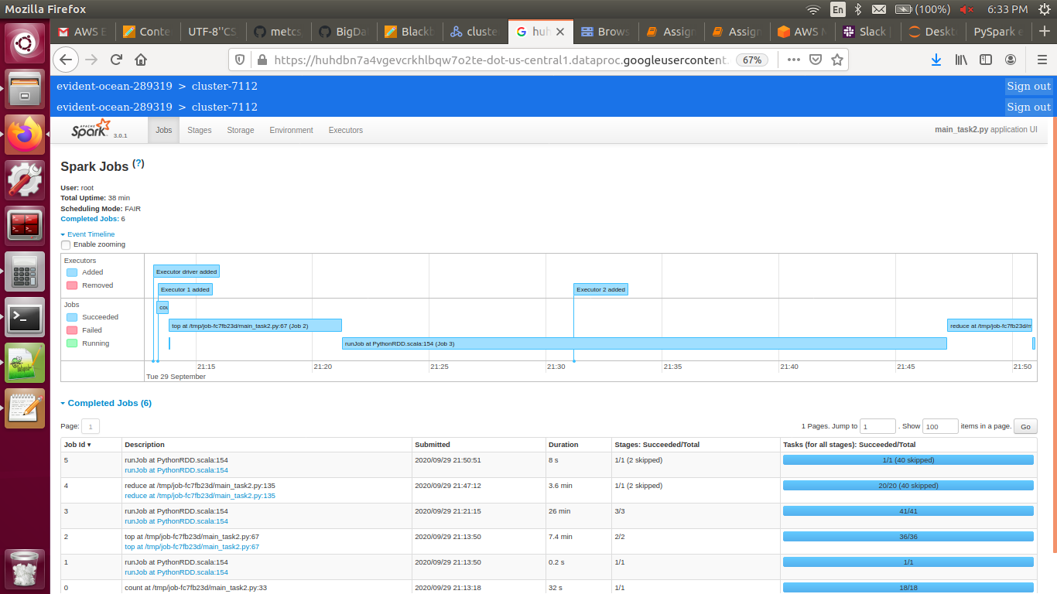
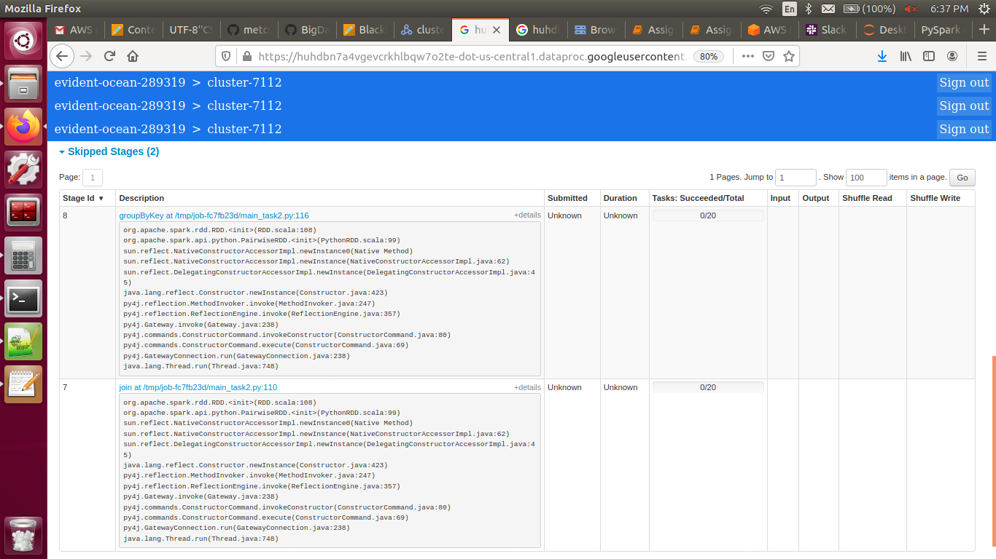

Task 3:
[('All_disambiguation_pages', 2), ('Disambiguation_pages_with_short_description', 2), ('Disambiguation_pages', 2), ('All_article_disambiguation_pages', 2), ('All_stub_articles', 1), ('1936_in_basketball', 1)]

[('All_article_disambiguation_pages', 3), ('All_disambiguation_pages', 2), ('Disambiguation_pages_with_short_description', 2), ('Disambiguation_pages', 1), ('Redirects_to_sections', 1), ('Airport_disambiguation', 1)]

[('All_disambiguation_pages', 2), ('Disambiguation_pages_with_short_description', 2), ('Disambiguation_pages', 2), ('All_article_disambiguation_pages', 2), ('2004â05_in_Central_American_football_leagues', 1), ('2004â05_in_Honduran_football', 1)]

Spark History:
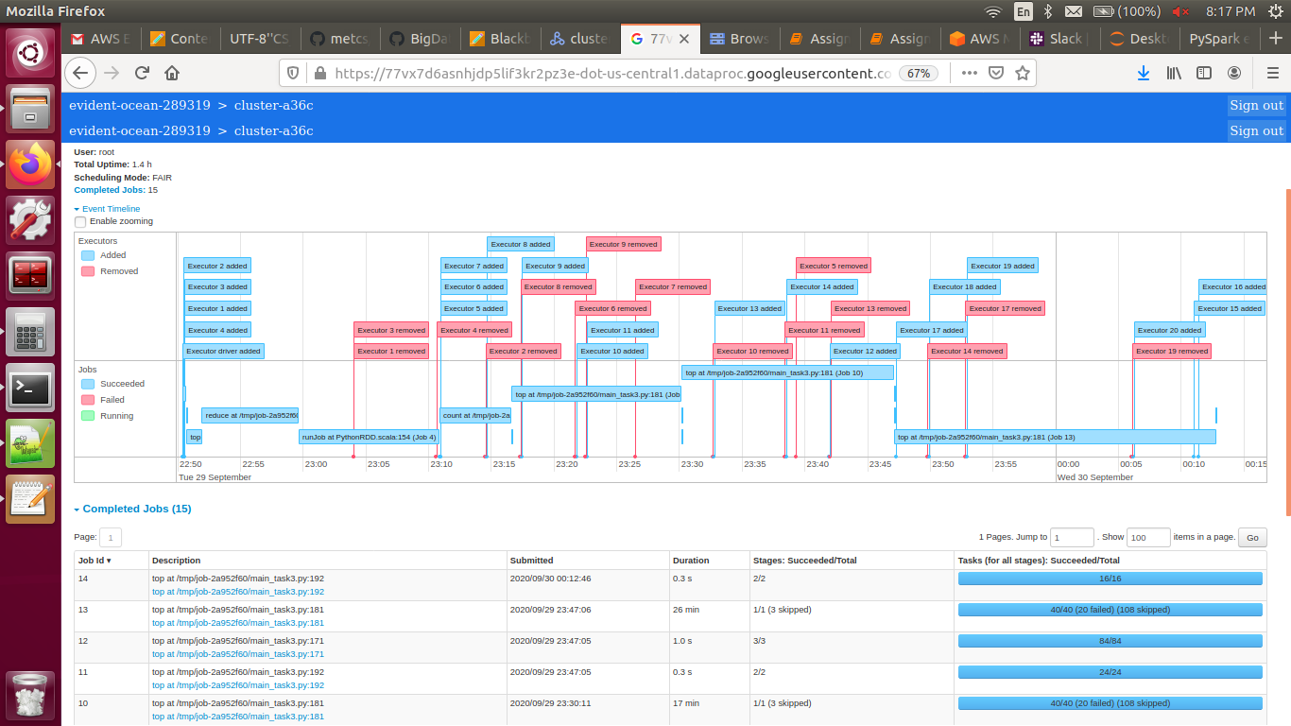
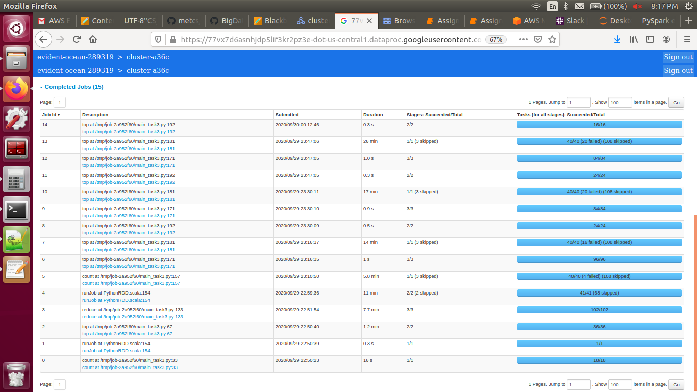
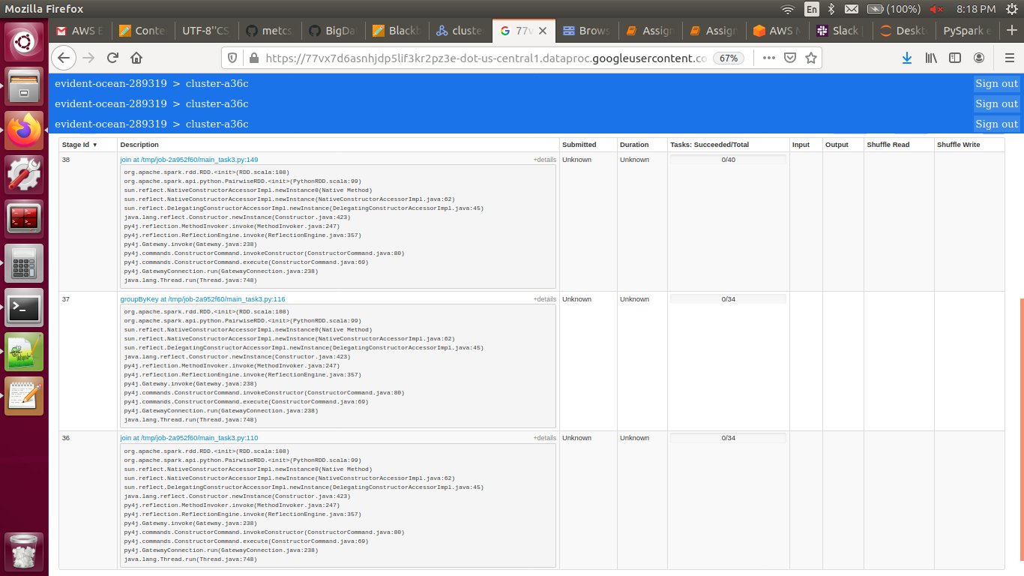
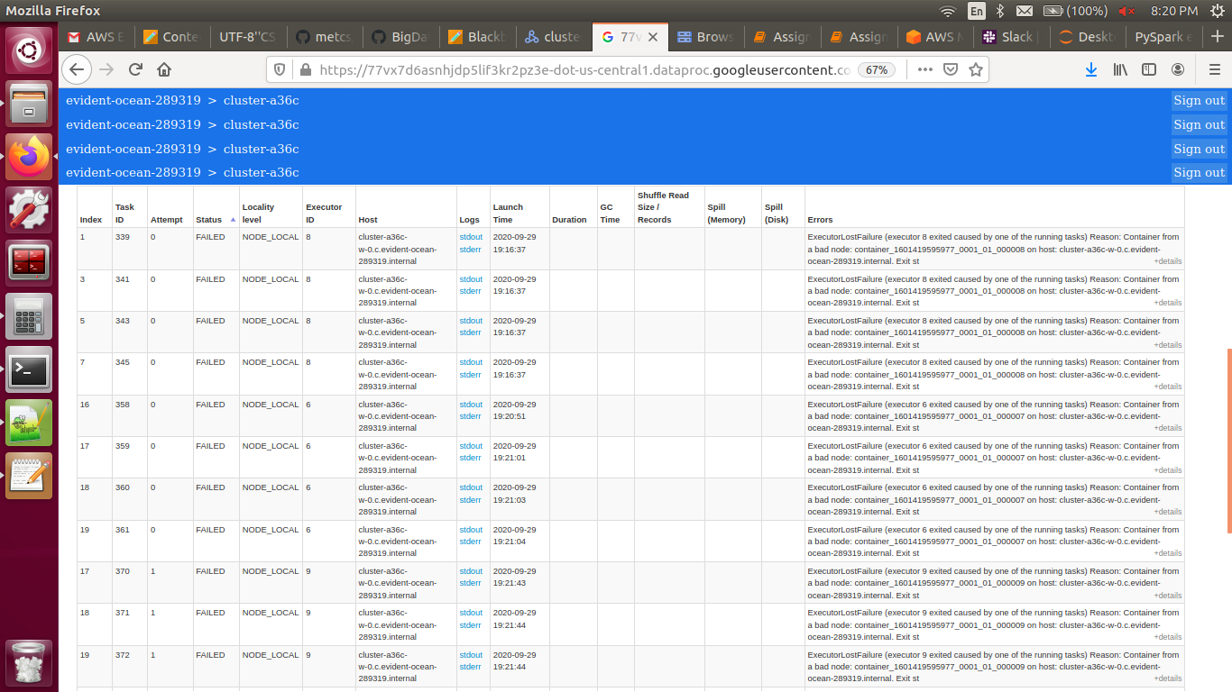

Task 4:
Top Words in Corpus: [Row(words='the', count(words)=26379566), Row(words='of', count(words)=12472066), Row(words='in', count(words)=10782521), Row(words='and', count(words)=10729878), Row(words='a', count(words)=7966514), Row(words='to', count(words)=7661172), Row(words='was', count(words)=4580330), Row(words='is', count(words)=3733368), Row(words='for', count(words)=3136608), Row(words='as', count(words)=3058023)]

Word Postions in our Feature Matrix. Last 20 words in 20k positions: [Row(words='quarterbacks', dictNum=19999), Row(words='depletion', dictNum=19998), Row(words='losers', dictNum=19997), Row(words='grumman', dictNum=19996), Row(words='shootings', dictNum=19995), Row(words='bump', dictNum=19994), Row(words='batavia', dictNum=19993), Row(words='riparian', dictNum=19992), Row(words='inefficient', dictNum=19991), Row(words='misuse', dictNum=19990), Row(words='discounted', dictNum=19989), Row(words='blackmail', dictNum=19988), Row(words='analysed', dictNum=19987), Row(words='coco', dictNum=19986), Row(words='rumor', dictNum=19985), Row(words='judas', dictNum=19984), Row(words='reappeared', dictNum=19983), Row(words='ub', dictNum=19982), Row(words='christophe', dictNum=19981), Row(words='lute', dictNum=19980)]

+--------+--------------------+
| key| NumpyArray|
+--------+--------------------+
|10000591|[0.005524862, 0.0...|
|10007113|[0.02, 0.02, 0.02...|
|10009278|[0.02173913, 0.02...|
+--------+--------------------+
only showing top 3 rows

+--------+--------------------+
| key| TFidf|
+--------+--------------------+
|10000591|[0.026643403, 0.0...|
|10007113|[0.09644912, 0.02...|
+--------+--------------------+
only showing top 2 rows

[Row(category='All_articles_needing_additional_references', count=2), Row(category='Articles_needing_additional_references_from_January_2018', count=2), Row(category='1996_in_basketball', count=1), Row(category='1939_in_basketball', count=1), Row(category='1994_in_basketball', count=1), Row(category='Basketball_stubs', count=1), Row(category='1995_in_basketball', count=1), Row(category='1927_in_basketball', count=1)]

[Row(category='All_Wikipedia_articles_written_in_Australian_English', count=2), Row(category='Use_Australian_English_from_August_2019', count=2), Row(category='Coordinates_on_Wikidata', count=2), Row(category='Articles_with_short_description', count=1), Row(category='Australian_Statistical_Geography_Standard_2016_ID_same_as_Wikidata', count=1), Row(category='City_of_Shellharbour', count=1), Row(category='Use_dmy_dates_from_August_2019', count=1)]

[Row(category='Articles_with_short_description', count=2), Row(category='CS1_Spanish-language_sources_(es)', count=1), Row(category='March', count=1), Row(category='Days_of_the_year', count=1), Row(category='1800_in_science', count=1), Row(category='Wikipedia_indefinitely_move-protected_pages', count=1), Row(category='Wikipedia_pending_changes_protected_pages', count=1), Row(category='1800s_in_science', count=1), Row(category='18th_century_in_science', count=1)]

Spark History:
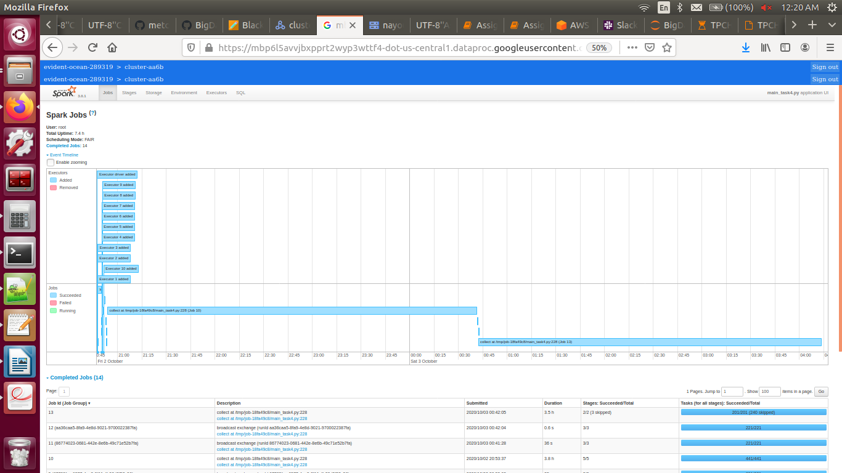
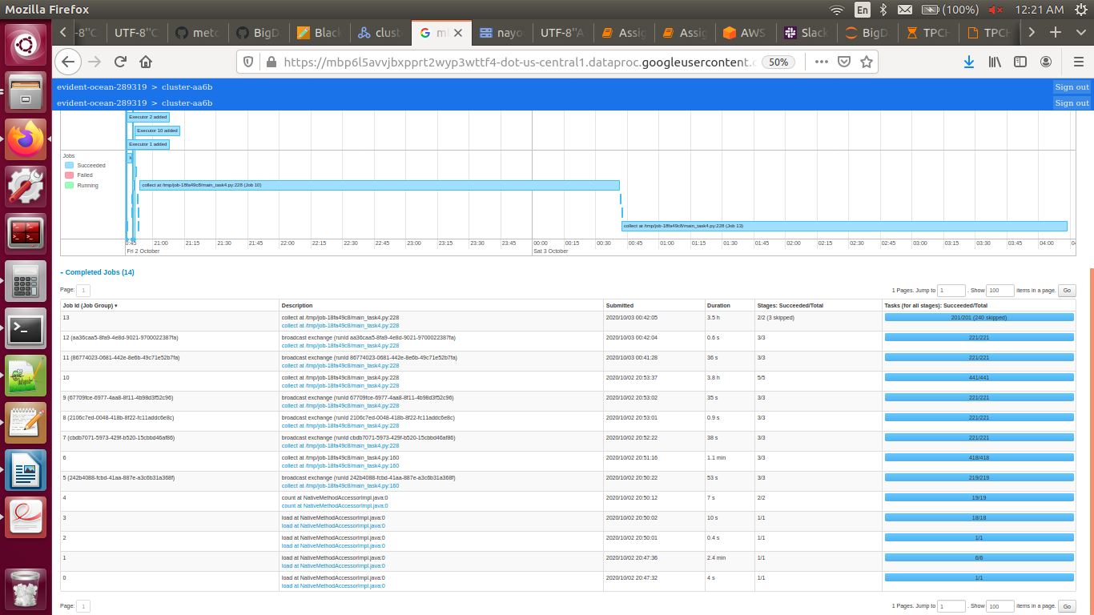

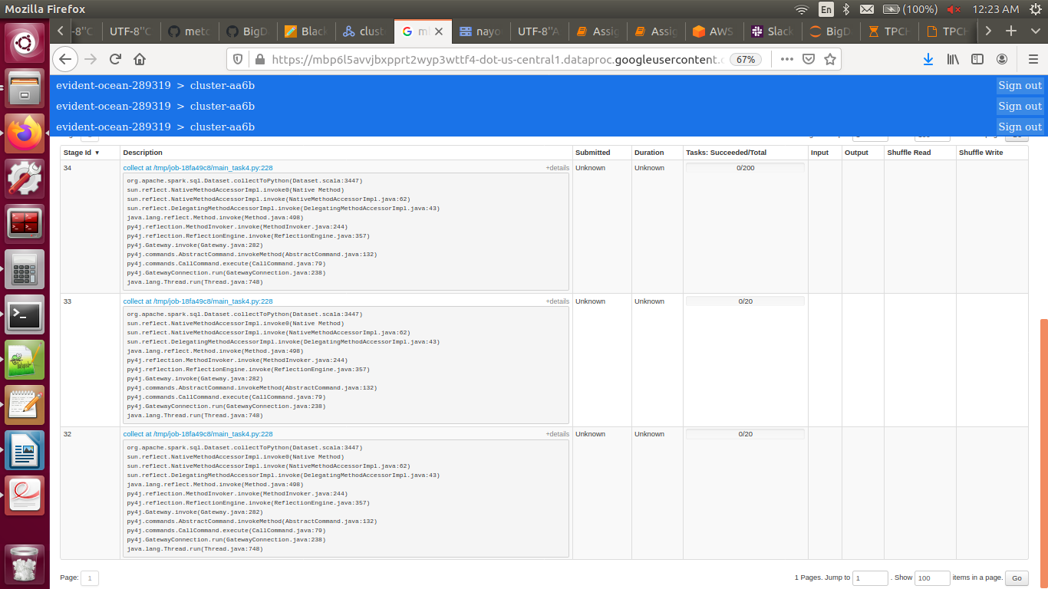

Task 5:
5.1:
I believe that removing stop words in this implementation would be a good and useful pre-processing step because;
1. Since we’re dealing with top 20K words, removing stop words (which are highly repetitive) would allow more space for other words to be included in the implementation which would result in a broader model.
2. Even if the model was dealing with all words (not just top 20K), it would still be good to remove them because in that case it will improve performance (less words to process).
3. Removing them can give more accurate results. For example, if input query was “What is the capital city of Australia?” the predicted categories/tags will be more focused on the actual topic (capital, city & Australia) instead of also accounting for the stop words that don’t contribute much to the information needed.

5.2:
Just like with stop words, stemming would also be a good and useful pre-processing step for reasons similar to the above;
1. Stemming would unit different forms of words into one form which in turn allows for more words to be included in the model.
2. It will also increase performance in case of using all words instead of only top 20K since there will be less words to deal with and process.
3. Since this model is used to predict categories and tags instead of translate, for example, then only one form of a word should be enough to produce desired accurate results and keeping all forms would be unnecessary and would require longer processing time.

